[[1]](#footnote-1)

Multiview banknote recognition with component and shape analysis

Carlos Miguel Correia da Costa

*Abstract*—Robust banknote recognition in different perspective views and in dynamic lighting conditions is a critical component in assistive systems for visually impaired people. It also has an important role in improving the security of ATM maintenance procedures and in increasing the confidence in the results computed by automatic banknote counting machines. Moreover, with the proper hardware, it can be an effective way to detect counterfeit banknotes. With these applications in mind, it was developed a system that can recognize multiple banknotes in different perspective views and scales, even when they are part of cluttered environments in which the lighting conditions may vary considerably. The system is also able to recognize banknotes that are partially visible, folded, wrinkled or even worn by usage. To accomplish this task, the system is based in image processing algorithms, such as feature detection, description and matching. To improve the confidence in the recognition results, the contour of the banknotes is computed using a homography, and its shape is analyzed to make sure that it belongs to a banknote. The system was tested with 82 test images, and all Euro banknotes were successfully recognized, even when there were several banknotes in the same test image, and they were partially occluded.

*Index Terms*—Banknote recognition, feature detection, feature description, feature matching, inliers filtering, multiview recognition, noise reduction, shape analysis

# INTRODUCTION

B

anknotes play a critical role in our trading society, and although digital currency is becoming more popular, physical banknotes still account for a large amount of the local transactions. As such, systems that are able to recognize banknotes can be applied to aid in the manipulation of this type of currency.

These kind of systems are critical to visually impaired people, since they allow them to be more independent while avoiding the help of untrusted people. Also, they can increase the security and reliability of ATMs [1], by making sure the maintenance operations are performed correctly and the valid banknotes are not replaced with counterfeits. Other less critical applications are related with automatic sorting and counting of banknotes to speedup transactions and money transfers.

For these types of systems to be effective and useful, they must be able to recognize the banknotes in several perspective views, scale dimensions, and should also tolerate cluttered environments with different lighting conditions. Besides these critical requirements, in order to be properly used to help visually impaired people, they should also be able to recognize folded, wrinkled and worn banknotes.

For the implementation of the robust banknote recognition system, the input images are preprocessed to remove environment noise and improve contrast and brightness. Then important keypoints and their associated descriptors are computed, to later be used to find the best matching in a database of valid banknotes. The correct matching of keypoint descriptors is critical to ensure the proper recognition of the banknotes. As such, methods to filter the inliers from the matches are employed. There are several techniques to perform such filtering, such as the ratio test (presented in section 7.1 of [2]) and the homography outlier removal (chapter 3 of [3]). Although these techniques can yield very good results, a postprocessing analysis is applied to make sure the results obtained are really banknotes. This is related to the fact that the matching of several parts of wrinkle banknotes may result in the recognition of multiple instances of the same banknote. In addition, images similar to banknotes or from other countries banknotes may yield incorrect partial matches. As such, this postprocessing phase is critical to ensure the correct recognition of the banknotes. It starts by computing the banknote contour using the retrieved homography, and then removes any result that has a convex contour, or has its area, circularity and aspect ratio outside the acceptable ranges for banknotes. To detect multiple banknotes in the same image, the inliers of the last recognized banknote are removed and the process presented earlier is repeated until there are no more valid matches.

In the following section it will be presented an overview of the several approaches that can be used to perform banknote recognition. In section III a detailed description of the implementation will be provided. In section IV the representative results of the recognition system will be provided and in section V it will be discussed the robustness of the system.

# Related work

There are several approaches that can be used to successfully recognize banknotes [4], and they range from simple but less robust techniques to more advanced and accurate systems.

The simplest technique is to use template matching to try to find the banknotes in the image by simple bitmap comparison. But this has the problem that both the reference banknotes and targets in the image must have the same size and perspective view. To mitigate this restriction, the comparison could be done in several scales and orientations, but it wouldn’t be very efficient. The dynamic template matching proposed in [5] could be used instead, but it still isn’t the best way to handle the recognition.

Other way to tackle this problem would be to perform color and shape segmentation of specific parts of the banknotes, like the method proposed in [6]. But this can complicate the implementation since it would have to be tuned to each specific banknote, and it would require a lot of effort to successfully recognize all banknotes from both sides.

A more broad implementation could use the size, color and texture of each banknote to perform the recognition [7], but like the previous case, it would require fine tuning to recognize each banknote, and would have to take in consideration the accuracy of the distance measurements, because several banknotes may have similar sizes.

A more robust implementation could use Principal Component Analysis or even adapt the eigenfaces algorithm to try to recognize the banknotes [8], but this can have some problems when the perspective of the reference banknotes is very different from the ones in the image.

For detection of counterfeit banknotes, ultra violet or infra-red light could be used to highlight specific parts of the banknotes that are hard to duplicate and easier to recognize [9]. Other similar technique takes advantage of the fact that specific parts of the banknotes are highlighted when they are illuminated with LEDs with different colors and intensities [10]. And another approach takes in consideration the electromagnetic fields present in sections of the banknotes to perform the recognition [11]. But all these techniques require special hardware that is too expensive. Moreover, they are not meant to be used by visually impaired people.

One of the most common techniques applied to banknote recognition uses machine learning algorithms, such as Support Vector Machines [12]–[14], Artificial Neural Networks [15]–[17], and Hidden Markov Models [18], [19]. These techniques usually apply some sort of clustering of features before training the classifier, such as the Bag of Keypoints model [20], or try to extract relevant features from the reference images. After the training, the classifiers can be used to recognize the banknotes. Although this is a good approach to general recognition, it may not be very precise in calculating the exact location and contour of the banknotes.

After the state of art review, it was considered that the technique that was likely to have the best results, and could be efficiently implemented, had to rely in algorithms that detected important features in the reference banknotes. Moreover, these features should be able to be correctly matched in the test images even if the banknotes were in different perspectives and in different lighting conditions. As such, an approach based in detection of edges [21], corners [22], blobs [23] and even ridges, could yield the identification of keypoints that could be successfully matched in the conditions presented earlier. For this matching to succeed, a scale and rotation invariant descriptor should be computed for each keypoint, using for example SIFT [2] or SURF [24] algorithms. After this matching, an outlier removal step could be applied to improve the accuracy of the detection, and the final recognition could be analyzed to make sure it was really recognized a banknote. This kind of approach has proved that it can achieved very good results, as shown in [25]–[27].

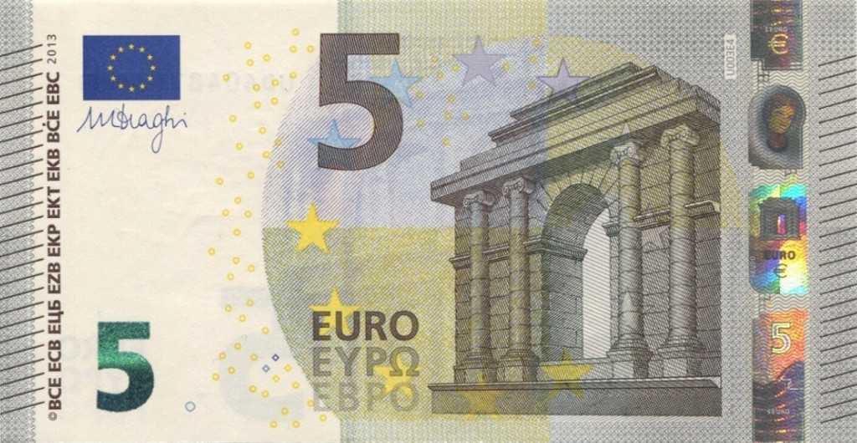

# Implementation

In the following sections the main steps of the implementation will be presented. The C++ source code along with the complete results are available at [28]. To speed up development, the OpenCV library was used.

## Preprocessing

To improve the detection of good features and ensure that the system has robust recognition even when the images have considerable noise, a preprocessing step is applied.

In a first phase, most of noise is removed using a bilateral filter [29]. This filter was chosen because it preserves the edges of the image blobs, which are very valuable structures in the detection of feature points.

After the noise is reduced, a CLAHE (Contrast Limited Adaptive Histogram Equalization) [30] is applied to increase the contrast. This can improve the recognition of the system when the images are taken in low light environments. This technique has better results over the simple histogram equalization because it can be applied to images that have areas with high and low contrast, and also limits the spread of the noise.

Finally, the brightness is adjusted to correct images that are too dark or too bright.

## Reference image database setup

In order for the system to be able to recognize the target banknotes, a database of valid instances must be computed.

This database contains the descriptors associated with the keypoints for each banknote (from both sides). These descriptors are calculated in the same way as presented in section C1 and C2 and the images are also preprocessed.

To improve the detection of the relevant parts of the banknotes and to avoid the usage of sections that are similar across several banknotes, the keypoint detection algorithm is only applied inside the masks associated with each banknote. Only relevant parts such as the banknote number and unique textures or patterns are included in the banknotes masks (as shown in Fig. 1).

Fig. 1. Banknote feature detection mask.

## Recognition

The recognition is the most critical phase in the system, in which the provided image is analyzed to extract the banknotes monetary value and their contour.

The current implementation supports recognition of multiple banknotes in the same image, even if they are partially occluded.

The system was implemented to recognize any type of banknotes. The Euro currency was selected for the computation of the results, but any other currency can be used. To setup the system for other currencies it is only necessary to replace the database images and masks with the intended currency images.

To improve the robustness of the system, 3 levels of detail for each banknote are provided (256, 512 and 1024 pixels wide images).

In an ideal banknote matching technique, the image resolution of both the reference and the target images should be the same. But this has a considerable overhead in the system performance, and as such, to allow the system to be more efficient and able to run in real time, a compromise between precision and computation time was achieved by precomputing the reference images in 3 different scales. At run time, the appropriate level of detail is selected according to the resolution of the target image.

The reason for several levels of details is related to the fact that the geometry of the banknotes changes drastically from a very low resolution to a high resolution banknote image. As a result, the computed keypoints and their associated descriptors will be considerably different and the recognition of the banknotes will likely fail. This can be clearly seen in Fig. 2.

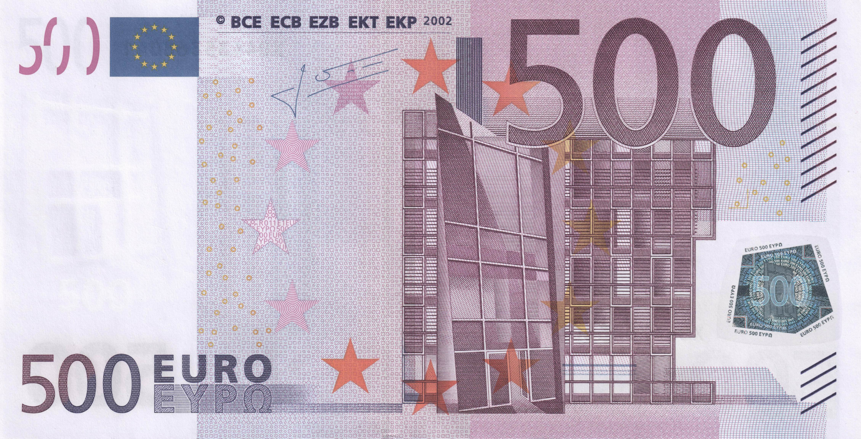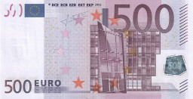

Fig. 2. Difference of detail from a very low resolution image (left) to a high resolution image (right) of the hologram of a 500€ banknote.

### Feature detection

Feature detection is the initial recognition step in which interesting keypoints for matching are identified in the image.

These keypoints are normally selected by analyzing the edges, corners, blobs or even ridges. Also, the keypoints provide a condensed representation of the image, which significantly speeds up matching (compared to bitmap or blob matching).

To allow fine tuning of the system, the implementation supports the usage of several feature detection algorithms. Namely, SIFT [2], SURF [24], GFTT [21], FAST [22], ORB [31], BRISK [32], STAR [33] and MSER [23].

### Keypoint descriptor extraction

The feature description step associates to each keypoint a description of its surroundings, in order to allow the matching of keypoints. This normally involves the computation of n-jets or local histograms and the final result is a vector in an n-dimensional space characterizing each keypoint.

In order to detect instances with different perspective views, these descriptors must be scale and rotation invariant. Also, they should tolerate different lightning conditions.

There are several algorithms that can accomplish this task, and as such, they were included in the implementation and can be selected to fine tuning the system. It was included the SIFT [2], SURF [24], FREAK [34], BRIEF [35], ORB [31] and BRISK [32] feature descriptors.

### Descriptors matching and inliers filtering

In order to detect multiple banknotes in the same image, a correct matching between the image descriptors and the reference banknotes descriptors must be establish. Moreover, these matches should be verified to see if they really belong to a banknote.

The initial matching can be performed using either a brute force or a heuristic approach.

In the brute force approach, each descriptor in the image is compared with all descriptors in the reference image to find the best correspondence.

In the heuristic approach, such as the FLANN library [36], several optimizations are employed to speed up the computations. These optimizations can be related to the appropriate selection of which keypoints to match, and to the use of efficient data structures to speed up the search (such as k-d trees).

After the initial matching, an inliers filtering phase is applied. It starts by applying a ratio test and then refines the results with the computation of a homography.

In the ratio test, each image keypoint descriptor is associated with the two best reference image descriptors. This allows to decide if the matching is correct or not, by computing the ratio between the distances of these references keypoints. The rationale behind it, is that if the ratio is close to 1, then there are two points with equivalent match probability, and as such, is very likely that this is an incorrect match, and should be discarded.

The refinement of the inliers is performed with the computation of a homography that allows the mapping of the positions in the reference image to the positions in the target image, in which the banknotes to be recognize reside. This is achieved by using the RANSAC [37] method to find the homography that best fits the detected keypoints. Since this is a RANdom SAmple Consensus method, it iteratively tries to find better results by randomly selecting the supporting keypoints until there is a high confidence in the results or the maximum number of iterations is reached. The rationale behind using such method, is that the geometry of the banknotes is planar, and if it is assumed that in most cases the banknotes that are going to be recognize have also planar geometry, then a homography can be used to analyze if a match is correct or not. This classification is performed by applying the homography to the reference keypoints and see if the result position in the target image is close to the position of the matched keypoint. If it is, then the match can be considered correct.

Having the inliers, two approaches can be used to decide if a valid banknote was found or not.

One technique relies in the computation of the global inliers ratio in relation to the number of keypoints, and considers that there was a correct match if this ratio is above a given threshold. This is the most appropriate method for most of the cases of recognition.

Another method that may yield better results when the banknotes are partially occluded, is to considering a correct match when one of the components of the masks (shown in Fig. 1) have the local inliers ratio above a given threshold. The idea behind this approach is to consider each patch of the image represented in the mask as a unique identifier of the banknote. As such, if this local patch is correctly detected, then there is a high confidence that the recognition of that banknote was successful.

### U:\GitHub\Currency-Recognition\Results\Object reconition\5__(5).jpg___SIFT-Detector_SIFT-Extractor_BF-Matcher_lowQualityImageDB_globalMatch__inliersMatches__0.jpgShape analysis

When a banknote matching is considered valid, it undergoes a postprocessing step in which its contour shape is analyzed.

This step is crucial to avoid the multiple detection of the same banknote when it is wrinkled or folded. Also, it removes any recognition that have a contour shape that can’t be associated with a banknote.

The initial filtering is performed by removing any result which have a contour with a very low area in relation to the whole image.

In a second step, any result without a convex contour is also removed. This is applied because a banknote has a convex quadrilateral shape. It will never have a concave shape, even when it is folded. The reason for this is that the contour is not computed from the banknote borders. Instead a homography is used to map the 4 corners of the reference image to the positions in the image in which the banknotes reside.

A final step removes any result that has a contour with a circularity or aspect ratio outside the acceptable bounds. These bounds are retrieved from a database of valid shapes, as shown in Fig. 3.

Fig. 3. Database of valid instances of banknote shapes

### Detection of multiple banknotes

In order to recognize several banknotes in the same image, the steps C3 and C4 are performed to every banknote reference image, and the best match is chosen. After the retrieval of the best match, its inliers are removed from the keypoint set, and steps C3 and C4 are repeated again for every reference image, in order to find another banknote. This is done until no valid match is found.

Only the inliers must be removed from the keypoint set in order to be able to successful recognize partially occluded banknotes. A less robust method (not used), that will likely fail, removes the keypoints that are inside the banknote contour. Although it might require less computations to perform, it will fail to detect banknotes that are on top of each other, because part of their keypoints will be removed when one of the banknotes is detected.

# Results

The system was tested with 82 images that contained banknotes in the most common conditions, such as different perspective views, cluttered environments, multiple banknotes per image and partially occluded banknotes. With the proper configuration (specified in [28]), the system successfully recognize all test images. Below are some of the representative results.

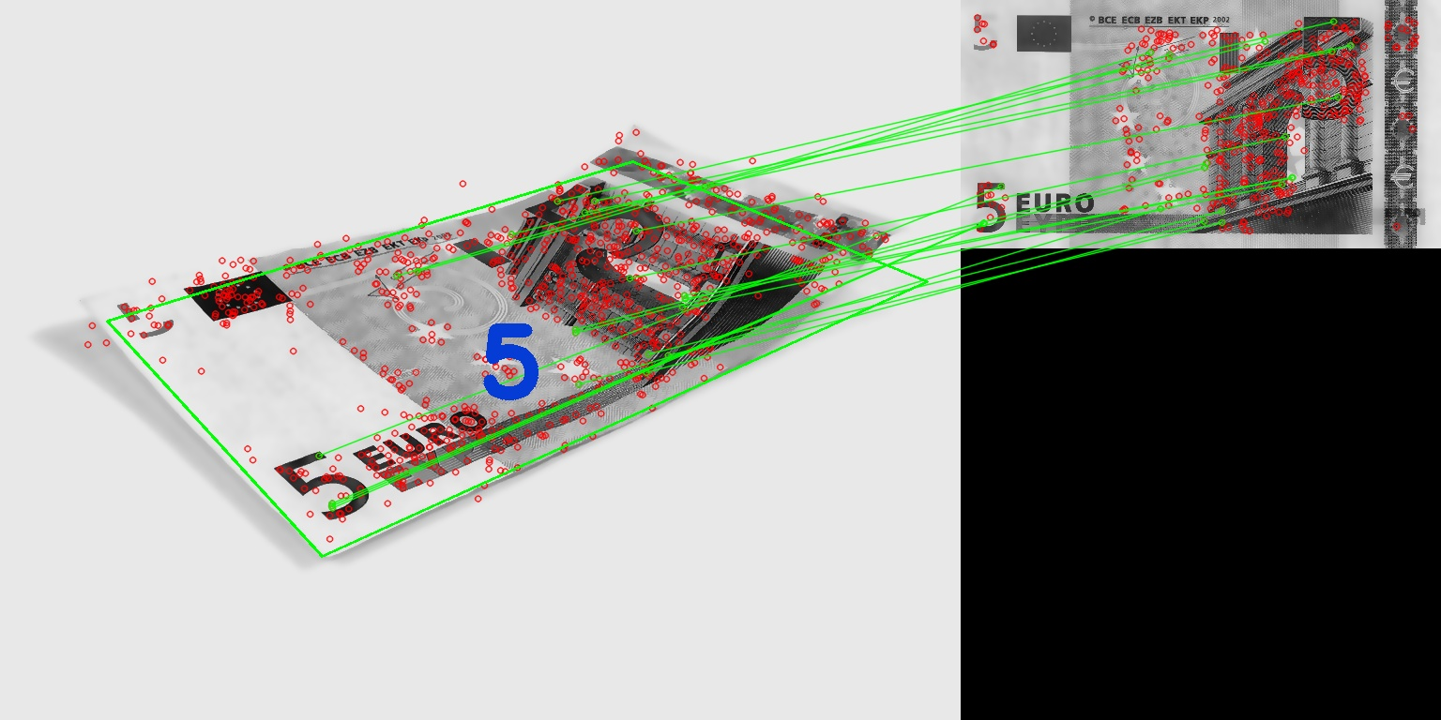Fig. 4. Detection of a banknote in an ideal perspective view.

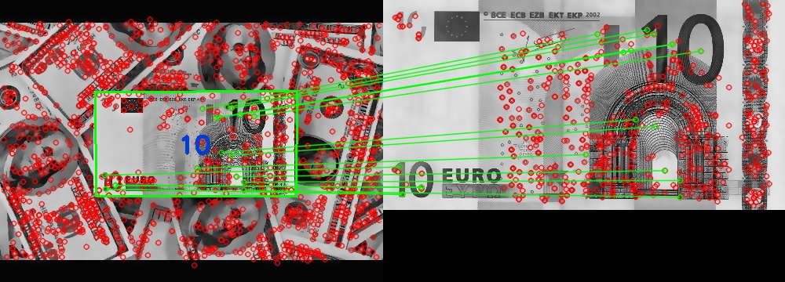Fig. 5. Detection of a banknote with perspective distortion.

Fig. 6. Detection of a banknote in cluttered environments.

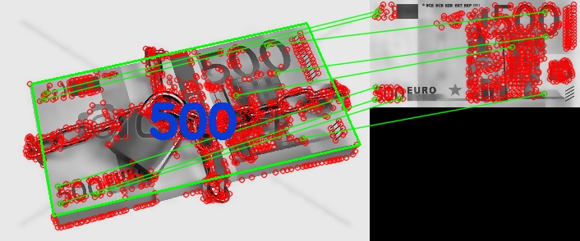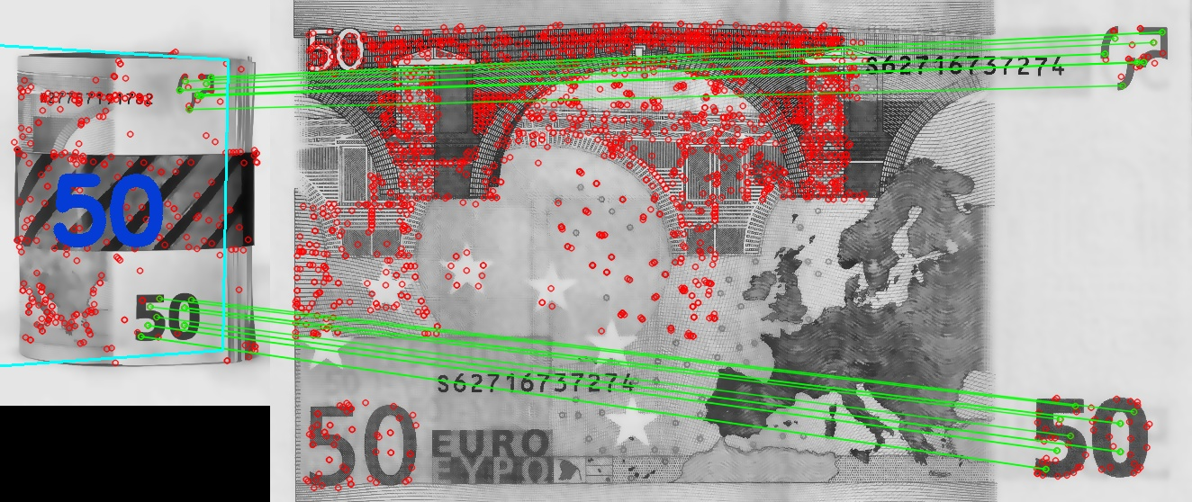

Fig. 7. Detection of partially occluded banknotes.

Fig. 8. Detection of overlapping banknotes.

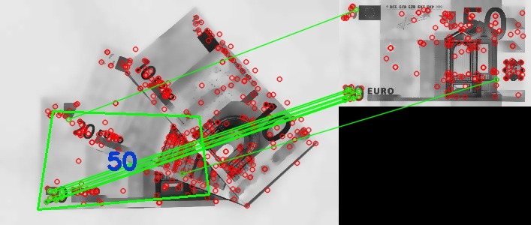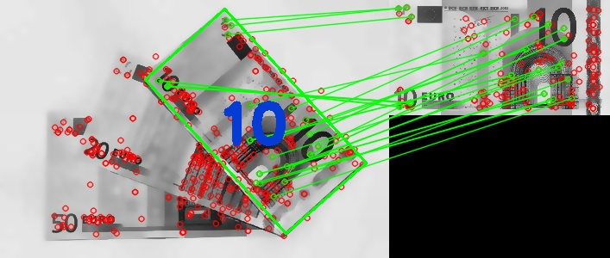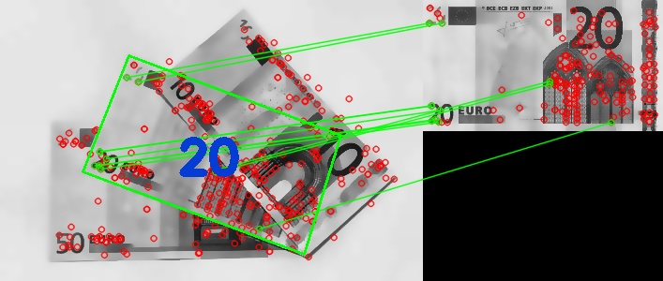

# Analysis of results

Several configurations were tested by combining different feature detectors with feature descriptors, and also using different approaches to perform the descriptor matching and inliers filtering. The best results were achieved with SIFT as detector and descriptor in conjunction with a brute force matcher and a global match inliers filtering method.

The best performance of SIFT is mainly related to the fact that it can select feature points that can be reliably detected even if the objects are in different perspective views. Moreover, it can compute descriptors that are robust to handle different lighting conditions.

For real-time use, the SURF feature detector and descriptor is more suitable, since it achieves similar results with significant less computation cost. This is achieved mainly due to the simplification of the computations by using integral images.

The brute force matcher, although slower than FLANN, achieved better results because unlike the heuristic approach it matches all descriptors in order to find the best correspondences. However, if the system is to be used in real time, FLANN can be employed with very similar results and lower computation time.

In relation to the inliers filtering method, the best results were achieved when the best matched reference image was selected based on the global inliers ratio. However for test images in which most of the banknotes regions were occluded, the local inliers ratio performed better. This occurred because the local matching of patches avoids the removal of recognition results that have low inliers ratio but in which these inliers are clustered in a small are of the banknote.

It should also be noted that the preprocessing stage allowed the successful recognition of banknotes even when there was significant noise present. Fig. 9 shows the impact of the preprocessing stage in an image which had noise caused by the wrinkled plastic.

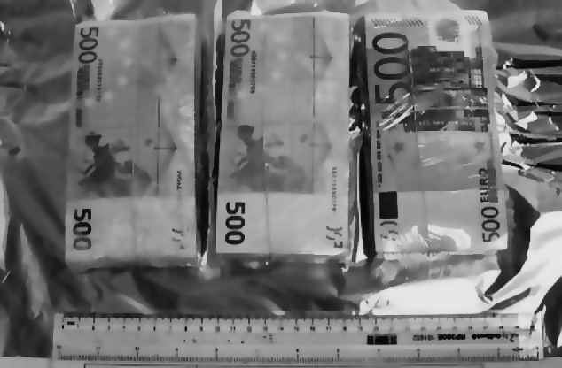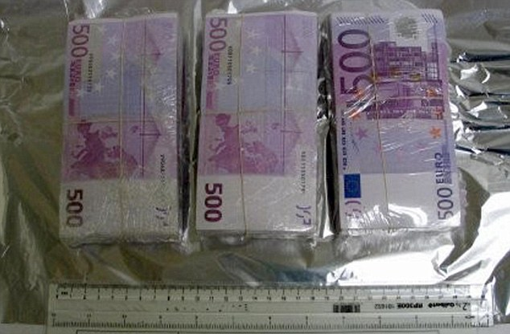

Fig. 9. Impact of preprocessing stage in the left image.

# Conclusion

The proposed recognition system achieved very good detection of banknotes even when they have significant perspective distortion or are partially occluded. It also was robust enough to handle folded and wrinkled banknotes with different kinds of illumination.

This was achieved by careful identifying the regions of the banknotes that had unique features, in order to avoid the usage of structures that are similar between banknotes. This technique in conjunction with the use of reference images with several levels of detail, were crucial to improve the correct matching of keypoints descriptors and ensure the correct recognition of the banknotes.

The system was configured to recognize Euro banknotes, but can easily be reconfigured to detect other currencies.

The achieved results make it a viable option to be used by visually impaired people or to improve automatic banknote counting machines and even increase the security of ATMs by detecting counterfeit banknotes.

References

[1] H. Sako and T. Watanabe, “Self-Defense-Technologies for Automated Teller Machines,” *Machine Vision and …*, 2007.

[2] D. Lowe, “Distinctive image features from scale-invariant keypoints,” *International journal of computer vision*, 2004.

[3] D. Baggio, S. Emami, and D. Escrivá, *Mastering OpenCV with Practical Computer Vision Projects*. 2012.

[4] D. Pawade, “Comparative Study of Different Paper Currency and Coin Currency Recognition Method,” *International …*, 2013.

[5] K. Nishimura, “Banknote recognition based on continuous change in strictness of examination,” *ICCAS-SICE, 2009*, 2009.

[6] Z. Solymar and A. Stubendek, “Banknote recognition for visually impaired,” *Circuit Theory and …*, 2011.

[7] H. Hassanpour, “Feature extraction for paper currency recognition,” *Signal Processing and Its …*, 2007.

[8] F. Grijalva and J. Rodriguez, “Smartphone recognition of the US banknotes’ denomination, for visually impaired people,” *ANDESCON, 2010 …*, 2010.

[9] B. Kim, E. Lee, and B. Suhng, “Feature extraction using FFT for Banknotes Recognition in a variety of lighting conditions,” *… and Systems (ICCAS), …*, 2013.

[10] M. Radványi and Z. Solymár, “Mobile banknote recognition: topological models in scene understanding,” *Proceedings of the 4th …*, 2011.

[11] S. Qian, X. Zuo, and Y. He, “Detection technology to identify money based on pulsed eddy current technique,” *… and Computing (ICAC), …*, 2011.

[12] C. Yeh, W. Su, and S. Lee, “Employing multiple-kernel support vector machines for counterfeit banknote recognition,” *Applied Soft Computing*, 2011.

[13] C. Chang, T. Yu, and H. Yen, “Paper Currency Verification with Support Vector Machines,” *Signal-Image Technologies and …*, 2007.

[14] B. Sun and J. Li, “The recognition of new and old banknotes based on SVM,” *… Information Technology Application, 2008. IITA’08. …*, 2008.

[15] J. Lee, S. Jeon, and I. Kim, “Distinctive point extraction and recognition algorithm for various kinds of euro banknotes,” *INTERNATIONAL JOURNAL OF CONTROL …*, 2004.

[16] S. Gai, G. Yang, and M. Wan, “Employing Quaternion Wavelet Transform for Banknote Classification,” *Neurocomputing*, 2013.

[17] B. Sun and J. Li, “Recognition for the banknotes grade based on CPN,” *Computer Science and Software Engineering, …*, 2008.

[18] H. Hassanpour and P. Farahabadi, “Using Hidden Markov Models for paper currency recognition,” *Expert Systems with Applications*, 2009.

[19] G. Shan and L. Peng, “The design of HMM-based banknote recognition system,” *… Systems, 2009. ICIS 2009 …*, 2009.

[20] G. Csurka and C. Dance, “Visual categorization with bags of keypoints,” *Workshop on statistical …*, 2004.

[21] J. Shi and C. Tomasi, “Good features to track,” *… , 1994. Proceedings CVPR’94., 1994 IEEE …*, 1994.

[22] E. Rosten and T. Drummond, “Machine learning for high-speed corner detection,” *Computer Vision–ECCV 2006*, 2006.

[23] J. Matas, O. Chum, M. Urban, and T. Pajdla, “Robust wide-baseline stereo from maximally stable extremal regions,” *Image and vision computing*, 2004.

[24] H. Bay, T. Tuytelaars, and L. Van Gool, “Surf: Speeded up robust features,” *Computer Vision–ECCV 2006*, 2006.

[25] F. Hasanuzzaman, “Robust and effective component-based banknote recognition by SURF features,” *Wireless and Optical …*, 2011.

[26] F. M. Hasanuzzaman, X. Yang, and Y. Tian, “Robust and Effective Component-based Banknote Recognition for the Blind,” *IEEE transactions on systems, man and cybernetics. Part C, Applications and reviews : a publication of the IEEE Systems, Man, and Cybernetics Society*, vol. 2011. pp. 1–6, 09-Jun-2012.

[27] I. Toytman and J. Thambidurai, “Banknote recognition on Android platform,” *unpublished. Available at: http://www. stanford. …*, 2011.

[28] C. Costa, “Currency-Recognition,” 2014. [Online]. Available: http://carlosmccosta.github.io/Currency-Recognition/.

[29] C. Tomasi and R. Manduchi, “Bilateral filtering for gray and color images,” *Sixth International Conference on Computer Vision (IEEE Cat. No.98CH36271)*, pp. 839–846, 1998.

[30] P. Heckbert, *Graphics Gems: IV*. Morgan Kaufmann, 1994, p. 575.

[31] E. Rublee and V. Rabaud, “ORB: an efficient alternative to SIFT or SURF,” *Computer Vision (ICCV …*, 2011.

[32] S. Leutenegger, “BRISK: Binary robust invariant scalable keypoints,” *Computer Vision (ICCV), …*, 2011.

[33] M. Agrawal, K. Konolige, and M. Blas, “Censure: Center surround extremas for realtime feature detection and matching,” *Computer Vision–ECCV 2008*, 2008.

[34] A. Alahi, R. Ortiz, and P. Vandergheynst, “Freak: Fast retina keypoint,” *Computer Vision and …*, 2012.

[35] M. Calonder, V. Lepetit, C. Strecha, and P. Fua, “Brief: Binary robust independent elementary features,” *Computer Vision–ECCV 2010*, 2010.

[36] M. Muja and D. Lowe, “Fast Approximate Nearest Neighbors with Automatic Algorithm Configuration.,” *VISAPP (1)*, 2009.

[37] M. Fischler and R. Bolles, “Random sample consensus: a paradigm for model fitting with applications to image analysis and automated cartography,” *Communications of the ACM*, vol. 24, no. 6, 1981.

1. [↑](#footnote-ref-1)